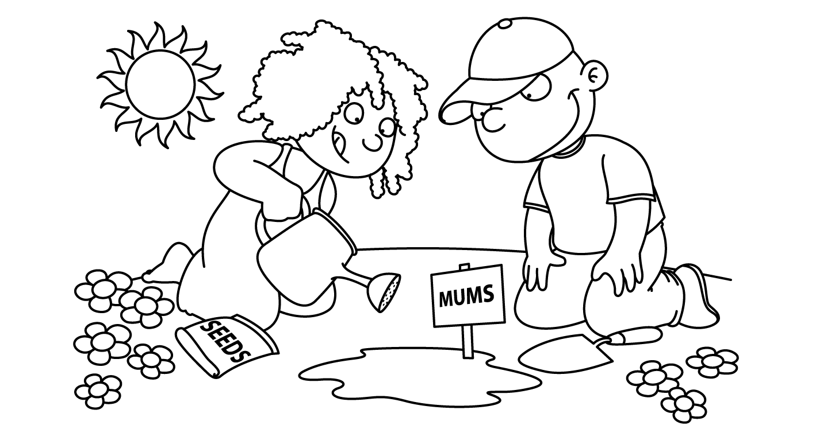

SGES APRIL 2015
Sunday | Monday | Tuesday | Wednesday | Thursday | Friday | Saturday
 |  |  | 1 | 2  NATIONAL Autism Awareness Day – wear blue | 3  Good Friday  No School | 4
5 | 6  Easter Monday  No School | 7  Choir  3:00-4:00 | 8 | 9  Wrestling  3:00-4:00 | 10  Paddington Movie at Community Center - 6:30 -  Donation at door | 11
12 | 13 | 14  6P & 6N Field Trip to Huntsman  Choir  3:00-4:00 | 15  6T to Field Trip to Huntsman  Home & School Meeting – 6:30 | 16 Wrestling  3:00-4:00  Get Ready For School Program starts for K 2015-16 | 17 | 18
19 | 20 | 21  Choir  3:00-4:00 | 22 | 23  Wrestling 3:00-4:00 (last day)  PSSC Meeting 6:30 | 24 | 25
26 | 27 | 28  Choir  3:00-4:00 | 29 | 30

