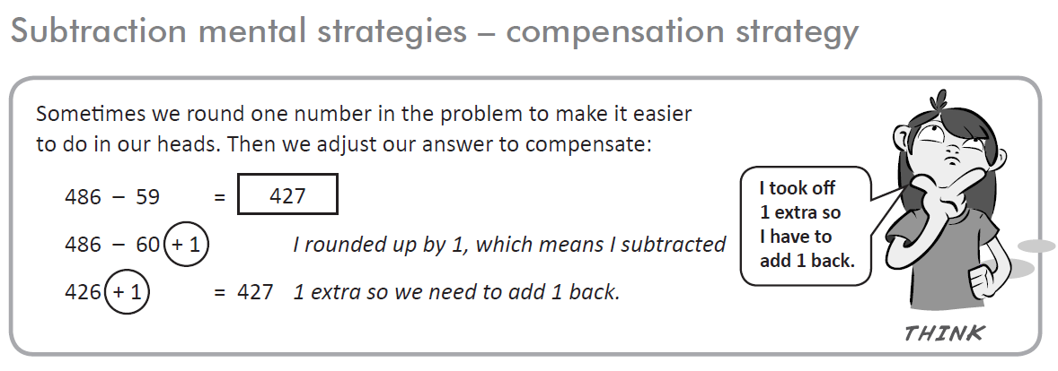

Practice: How many can you do in 3 minutes? Score:_________

- 585 – 78 = ____________
- 894 – 71 = ____________
- 163 – 149 = ____________
- 775 – 98 = ____________
- 644 – 139 = ____________
- 594 – 329 = ____________
- $10.00 – $7.01 = ____________
- 432 – 204 = ____________
- $9.56 - $6.99 = ____________
- 600 – 397 = ____________
- 100 – 289 = ____________
- 500 – 192 = ____________

